(Un-)Desirable Bodies: The Representation of the Gypsy Girl in Fine Art of the Austro-Hungarian Empire, 1867-1918

Ceri Beasant

Table of Contents:

List of Figures……………………………………………………………………… …3
Introduction……………………………………………………………………………5
Gypsies and Gender…………………………………………………………………..13
Race and Nation……………………………………………………………………....28
Modernity…………………………………………………………………………….39
Conclusion……………………………………………………………………………46
Bibliography………………………………………………………………………….49
Primary Sources……………………………………………………………………....49
Secondary Sources…………………………………………………………………....52

List of Figures:

Figure 1: János Valentiny, Fortune Teller, n.d., oil on canvas, 80 cm high x 64 cm wide, private collection………………………….………………………...............14
Figure 2: János Valentiny, A Kedvenc Nóta [My Favourite Song], n.d., oil on canvas, 130.5 x 164 cm, private collection……………………………….……...…..15
Figure 3: Károly Ferenczy, Gypsies, 1901, oil on canvas, 122 x 122 cm, Hungarian National Gallery, Budapest…………………………….................................18
Figure 4: Károly Ferenczy, Gypsy Girl, 1916, oil on canvas, 95 x 140 cm, Budapest History Museum Municipal Gallery…...……...……………...…………..…19
Figure 5: János Göröncsér Gundel, Gypsy Girl and Nude Model, c. 1907, oil on canvas, 69.5 x 59.5 cm, Hungarian National Gallery, Budapest.…....…………...…..20
Figure 6: Alois Hans Schram, Gypsy Girl with a Tambourine, 1895, oil on canvas, dimensions unknown, private collection..…………………..…………….....22
Figure 7: Alois Hans Schram, Gypsy Woman with Tambourine, 1899, oil on canvas, 64.5 x 50 cm, private collection..………………………................................22
Figure 8: Béla Iványi-Grünwald, Gypsy Girls by the Banks of the Lápos, 1909, oil on canvas, 115 x 115 cm, Maramures County Museum, Nagybánya……….......24
Figure 9: Béla Iványi-Grünwald, Lányok a Vízparton [Girls by the Waterside], c. 1910, oil on cardboard, 67 x 73 cm, private collection……………….…………….24
Figure 10: Alois Hans Schram, Beauté Orientale [Oriental Beauty], 1892, pastel on cardboard, 67 x 52 cm, private collection…...................................................34
Figure 11: Alphonse Mucha, Salomé, 1897, lithograph, 31 x 41 cm, private collection……………………………………………………………………36
Figure 12: Lajos Deák-Ébner, Boat Warpers, 1878, oil on canvas, 131.5 x 98 cm, Hungarian National Gallery, Budapest…...……...…….................................37
Figure 13: Kalman Borsodi, Gypsies, late nineteenth century, oil on canvas, dimensions unknown, private collection……………………….…..................................42
Figure 14: Kalman Borsodi, Gypsy Family in Landscape, nineteenth century, oil on panel, 21 x 16 cm, private collection...............................................................42

(Un-)Desirable Bodies: The Representation of the Gypsy Girl in Fine Art of the Austro-Hungarian Empire, 1867-1918

Renowned Romani historian David Crowe has said, ‘[i]n many ways, the Habsburg Roma, or Gypsies, are “a people without history.” Given their nomadic existence, they left little or no imprint on the political, economic, and cultural institutions of the various dominions through which they passed.’ Yet in Austro-Hungarian fine art in the period of dualism, the extensive documentation of Gypsies – and thereby their cultural imprint – is striking. The presence of a regular cast of ‘Gypsy’ characters in such paintings attests to the unsurpassed rise of fascination with the Romani in nineteenth-century Europe. Rather surprisingly, considering the stigmatisation of the Romani in this period, their representation more generally in art of the Austro-Hungarian Empire is not wholly negative, but entails a strange mix of innocent – childlike, rustic, non-educated, nomadic and collective – and non-innocent – carnal and criminal – characteristics. Throughout these depictions, the character of the young Gypsy girl emerges as a distinct and provocative figure. Hypersexualised, musical and rhythmic, destitute, inviting yet mysterious, she especially appears simultaneously desirable and undesirable. Efforts to untangle the paradox inherent in this tradition suggest that the figure is not only an expression of typical, pastoral tropes as a locus amoenus, but also of wider contemporary concerns and fascinations about femininity, race, and modernity. In this way, the study of the Gypsy girl illuminates conflicts in Austro-Hungarian society’s conceptualisation of these elements.
It would perhaps be more fitting for Crowe to say the Romani are ‘a people without History’, in recognition of the tension between the ubiquity of these images of the Gypsy and the scarcity of their academic, historical assessment. Indeed, Dutch historian Wim Willems refers more precisely to ‘[t]he still scarcely written history of Gypsies’. As such, the current state of Romani Studies consists largely of broad surveys and sweeping, complete histories but very few monographs. Moreover, Romani are largely missing from histories of Austria-Hungary, as is true of recent volumes by two of the field’s leading researchers. Steven Beller’s 2018 book mentions ‘Roma’ only once, and even then in a list of ethnic groups that the later Czechoslovakia would encompass. Pieter Judson’s work of 2016 is little better, with three indexed mentions of ‘Roma’ in his over five hundred page book. Despite claims to be ‘a new history’, Judson’s book fails to demonstrate a long-overdue sensitivity to the role of Austria-Hungary’s sizeable Romani population.
Specifically, an extended analysis of the figure of the Gypsy girl in fine art of the Austro-Hungarian Empire has not before appeared in English. Gábor Bencsik deals very briefly with the ‘erotic momentum’ in images of the Gypsy girl in his Hungarian Gypsy Picture Book: The Historic Iconology of the Gypsies in Hungary, 1686–1914. Whilst Bencsik successfully introduces the topic to public history, the book’s scope is broad with a sparse research grounding on the Gypsy girl. For example, Bencsik’s understanding of the eroticism of these images as a ‘misunderstanding between two cultures’ relies on the claim that Romani women were often topless, a stereotype which has been challenged by the assertions of most scholars working on Romani Studies. Moreover, although an English translation was published in 2013, the text is not widely available to an English readership. Therefore, this dissertation takes inspiration from other studies of representations in Romani History, such as the work of Sarah Houghton-Walker and Deborah Nord on British written sources, and Stewart Dearing on the pan-European Bohemian movement. Equally of note is the recent movement in ethnomusicology, fronted by Lynn Hooker, that lays out a course for historians and art historians alike to map out Romani representations in the visual arts. This movement additionally serves to highlight the complicated relationship between Hungarian and Romani identity that exists in relation to music, since the Gypsy musical style is often equated with the Hungarian style as a source of national pride – which, as this dissertation will later show, manifests itself in paintings of this period, too.
Crowe’s statement does call to mind the truth that it was generally not Romani actors, but non-Romani, or gadže, who were responsible for the cultural products of Austria-Hungary in which they appear. Whilst rewriting narratives of lived Romani history is an important and overdue task, this study maintains the emphasis on outsiders’ perspectives of Romani with the purpose of exposing these images as constructions and interrogating of a powerful motif. It is with this in mind that this dissertation employs the term ‘Gypsy’, taking Wim Willems’ definition of a ‘Gypsy’ as a member of a group defined as such by the outside, and thereby inherently a subject, rather than a member of a single and homogenous ethnic group (to reference which ‘Romani’ or ‘Roma’ is used).
As a result of the relative lack of scholarly attention given to the Gypsy subject in Austria-Hungary, a number of major conceptual frameworks have not been thoroughly employed to examine this history. Yet tropes exposed by feminist, postcolonial, and even ecocritical theory converge in the figure of the Gypsy girl – a member of a racial minority and gender characterised as closer to nature than civilisation. Hence, elements from all three disciplines, intersecting as they commonly concern the representation of an othered subject, may be useful tools in understanding these representations as the study moves through the discussion of the elements of gender, race, and setting.
Firstly, this dissertation will discuss how the presentation of the young, female, Gypsy body illuminates Austro-Hungarian fantasies and anxieties about women in the period of the Dual Monarchy. In a context of nascent female empowerment, female objectivity is reasserted through paintings that posit Romani women as familiar objects of desire. In this way, the Gypsy girl is generally presented as conventionally beautiful and alluring. Focusing first on the paintings of János Valentiny, this section will show how the sexual appeal of the girl in her reproductive prime is highlighted by the artist’s choice of suggestive expression, pose, exposure and nudity. Feminist theory exposes the first of several different gazes through which the Gypsy girl is viewed, beyond simply that which is an implication of the artist-subject relationship. The ‘male gaze’, conceptualised by feminist theorist Laura Mulvey, offers a tool to deconstruct the composition of the female subject by male artists produced for a male-dominated market. Accordingly, it will be suggested how this perspective can be traced in the self-conscious nudes of the later Hungarian painters, Károly Ferenczy and János Göröncsér Gundel. This purpose of bringing pleasure to the male voyeur is all the more apparent in the portrayals of female Romani musicians and dancers, seen in the work of Alois Hans Schram, amongst others. Drawing on the Romani reputation for musicality, these representations place Romani women in the role of (often erotically charged) entertainer. At the same time, the conflict between the physical attractiveness of these figures and public hostility towards Romani in the Austro-Hungarian Empire suggests an unease over the sexual power of this figure, as exemplified through the crude sexuality displayed in the works of Béla Iványi-Grünwald.
The dissertation will then consider what this character reveals about conceptualisations of race in Austria-Hungary, beginning by discussing the aforementioned sexualisation of the character in a particular context of emergent scientific racism, nationalism, and the height of Orientalist fashion. The consistent eroticisation of nubile women found in these images supports the idea that both women and exotics were considered more bodily than cerebral. The concept of an ‘imperial gaze’ parallel to the ‘male gaze’ devised by postcolonial scholars building on Mulvey’s work is useful in assessing these images of Gypsies as imperial subjects depicted by those belonging to the dominant culture of Austria-Hungary. This combination heightened the desire of gadže Austro-Hungarians to record and thus define those seen as eastern foreigners within the empire, art being one way to do so.
For their attachment to broader tropes employed to depict subjugated groups, Gypsy women are sometimes hard to distinguish from other exoticised peoples in the art of the Habsburg lands from 1867 to 1918. Gypsy women as depicted in art of this period hence often bear a strong resemblance to depictions intended to be of Jewish and even folk Hungarian women, as other scholars on pictorial representations of Gypsies, such as Stewart Dearing, have observed. The similarity between imagery meant to depict these varying styles may be a practical constraint, resulting in a reliance on titles (which themselves may offer interesting information, usually when they present an essentialist vision of ‘The Gypsy’ or ‘The Gypsy Girl’) to identify the Gypsy subject, but does pose interesting questions. Whilst it remains that the Gypsy girl occupies a distinct and recognisable position amongst representations of Gypsies, these commonalities probe the extent to which these works of art presented a generalised exotic, and, as such, how far their positive and negative characteristics communicate Austro-Hungarian attitudes on supposed outsiders rather than Romani specifically.
Finally, the dissertation will consider how the representation of the Romani girl reflects upon ideas of modernity. As is indicated by the likeness between depictions of folk Hungarian women and Gypsy women, there was a semantic connection between the image of the Gypsy and that of the nation, particularly in the case of Hungary. However, the romanticisation of Gypsy lifestyle may also serve as a critique of the modern dynamic towards the controls of urbanity and industrialisation. The rural setting – complete with animals and tents for housing – and the clothing of the Gypsy girl, elements which will be explored in the work of Kalman Borsodi, suggest that the Gypsy girl is associated with a traditional (viewed in its extreme as primitive) rural lifestyle that was in the process of disappearing. The gaze here is that of a metropolitan artistic elite upon a pre-industrialised world. In this context, the musicality of the Gypsy girl may also be read as a repository of preserved folk culture where it had been lost amongst ethnic Hungarians in particular.
To conclude, I shall consider how these elements combine uniquely in the figure of the Gypsy girl, whose paradoxes suggest some of the tensions in a society undergoing unprecedented, accelerating change. Following on from my findings in the analysis of this character, I shall highlight similar areas within historical Romani Studies where further study would be useful.
The paintings discussed in this dissertation are indeed select examples, but they reflect a particular tradition of aestheticizing the Romani girl. By exploring the ambivalences held within this fascinating but hitherto largely unexamined character, this dissertation aims to show the historical understanding that can be gained from representations of Romani.
Gypsies and Gender

This section shall introduce the imagistic representation of the Gypsy girl by Austro-Hungarian artists, before assessing this aestheticized character in a gendered theoretical framework in order to discern what her prevalence suggests about conceptualisations of the female during the Dual Monarchy. Fin de siècle Europe saw a rapid increase in academic theorisations of gender (epitomised by Sigmund Freud in Vienna, 1900), matched by change in popular conceptualisations alongside the increased visibility of women. These developments and reactions to them can be traced in contemporary representations of the young Gypsy girl.
Images of the Gypsy girl in this period commonly share the large, dark eyes, voluminous, long, and curled dark hair, and golden, fully smooth skin, with no wrinkles a testament to her youth, all set in a slender, perfectly proportioned face and body. Speaking of the appearance of the Romani girl in German literature in the long nineteenth century, Nicholas Saul has grouped these elements as a ‘Romany pulchritude topos’ – which I believe can similarly be identified in late nineteenth and early twentieth-century Austro-Hungarian art. Indeed, these features will recur in the works of art included in this dissertation. In short, the Gypsy girl as imagined in the work of these painters is conventionally attractive.
Artists of all kinds are tempted to make their leading figures extraordinarily attractive. Yet the attractiveness of the Gypsy girl character is generally not the ethereal, inaccessible, and pure beauty typically venerated in European art of this period. Rather, it is a bodily and earthly beauty heavily imbued with sexual imagery. The work of Hungarian artist János Valentiny (1842-1902), a prolific painter of Gypsy life, repeatedly features the Gypsy girl as an aesthetic and sexual object. His painting, Fortune Teller, expresses this attractiveness within the framework of a dominant stock character of the female Gypsy in European representations (Figure 1). Although undated, we can suppose that, on account of Valentiny’s adult life being largely contained within the years of the Dual Monarchy, that it was produced in that period or, if not, in the years immediately prior. Rather than focusing on prophesying, the fortune teller’s large eyes look out of the frame enticingly, in a way that is typical of such paintings. She has long, dark hair made up of curls. Unblemished olive skin is shown as her pose foregrounds bare feet and arms, which also form a part of the Romany pulchritude topos identified by Saul. In this instance, the Gypsy girl additionally displays exposed shoulders, highlighted by their being angled towards the viewer.
Figure 1: Fortune Teller, by János Valentiny, n.d., oil on canvas, 80 cm high x 64 cm wide, private collection.
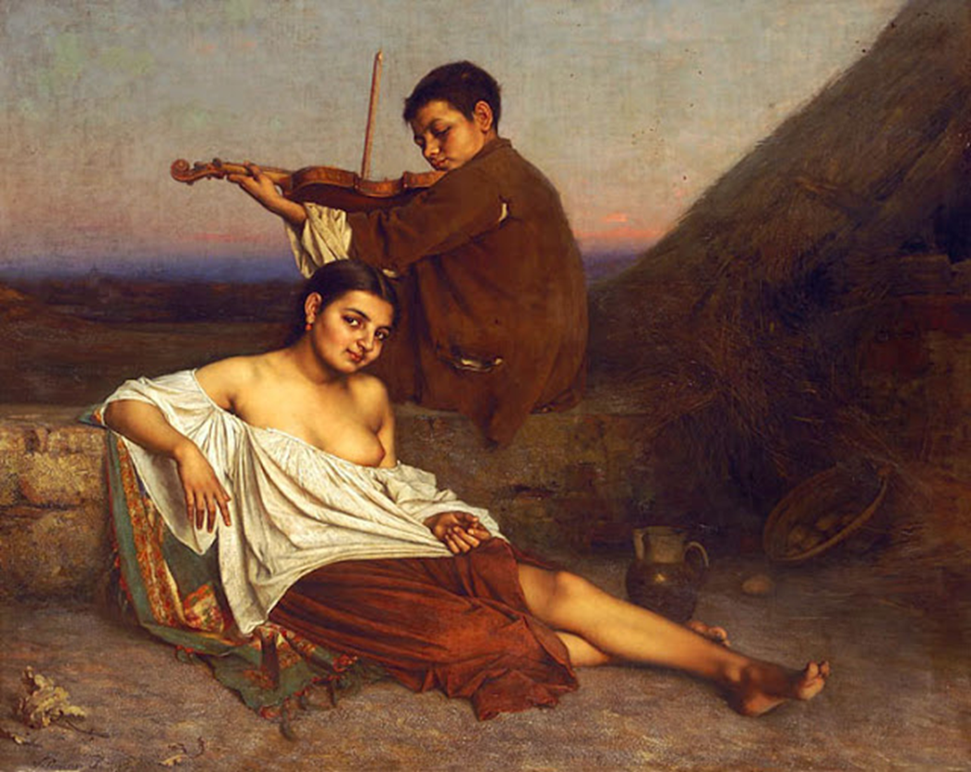
Suggestive exposure is even more striking in another painting by Valentiny. Although the title does not allude to Gypsies so clearly as The Fortune Teller, and the scene does resemble Valentiny’s Italian beach scenes, it can be deduced that A Kedvenc Nóta [My Favourite Song] depicts Gypsies, if in an Italian setting (Figure 2). At this point, it is worth clarifying what is meant by ‘art of the Austro-Hungarian Empire’: that is, art produced by artists from the lands of Austria-Hungary between 1867 and 1918 (in this case depicting Gypsies), rather than depictions of Austria-Hungary (which would be of Austro-Hungarian Gypsies) by artists of any ethnicity. Returning to My Favourite Song, one clue to the ‘nationality’ of the subject is the presence of the tawny young boy with a violin, dressed in rags. The boy is another Gypsy stock character in the artworks of Hungarians; he appears in several of Valentiny’s paintings that identify their Gypsy subject in their title, including Gypsy School. His presence suggests that his female companion is intended to be a fellow Rom, since scenes of interaction between Romani and gadže are rarely found in Austro-Hungarian paintings of this period, with the exceptions of the exchange of stereotypical Romani services, such as fortune telling, or, equally stereotypically, Romani stealing from gadže. More importantly for our purposes here, however, the girl (and it is she who attracts the attention of the viewer, with her locked gaze and suggestive titled head) also fits the criteria of the Romany pulchritude topos. Accordingly, she has large, dark eyes, dark, sleek hair, tanned and unmarked skin shown in exposed arms and feet, and a well-endowed breast on an otherwise slim-looking body. This time, her skirt is hitched up – apparently caught on nothing – to reveal most of her left leg and, also without explanation, one breast is hanging out, which is highlighted by her open posture. The girl is surely aware of this, but makes no effort to redress it. Such nudity is commonplace in representations of the Gypsy girl in this period.
Figure 2: A Kedvenc Nóta [My Favourite Song], by János Valentiny, n.d., oil on canvas, 130.5 x 164 cm, private collection.
The drawing of attention to the flesh of a nubile Gypsy woman, unnaturally uncovered by her tattered clothes, sometimes to reveal breasts; her attractiveness, her provocative stare; and her welcoming stance collectively result in the undeniable sexualisation of this figure. The nude in art is famously not always considered erotic, but the combination of these elements in the representation of the Gypsy girl produce an ‘overt sexuality’, as labelled by Colin Clark. Since Valentiny and the other artists I shall discuss in this dissertation are, as far as is known, heterosexual males, producing art in a largely patriarchal society primarily for consumption by other men, either by exhibition or by purchase, Laura Mulvey’s concept of ‘the male gaze’, though first developed in Film Studies, can be discerned in these paintings. Mulvey’s theory suggests that the young Gypsy women in these paintings fall into a passive role as the recipients of the male gaze. The implication is that these paintings, with their depiction of nude or semi-nude Gypsy girls, recognise and aim to fulfil a voyeuristic desire.
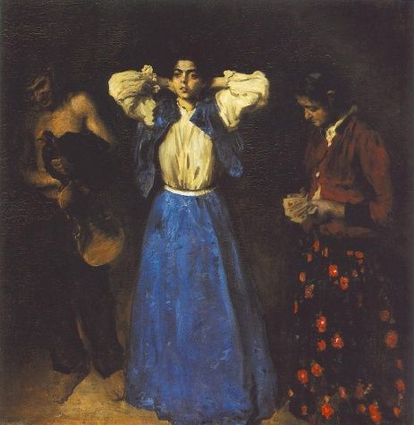
Paintings by Hungarian artists in the later years of this period – from the twentieth-century in the examples I have found – which depict Gypsy girls, seem to make explicit that figure’s role as a specimen for external representation. The celebrated Hungarian master, Károly Ferenczy (1862-1917), appears to do this on at least two occasions. The first is the 1901 painting Gypsies (Figure 3). It depicts three figures, each taking on the tropes of a different Gypsy stock character – the young, male, Gypsy fiddler, Gypsy mystic-hag, and is the young wide-eyed Gypsy girl. She is central both physically and thematically, the only figure completely in the light and visible. Art historian Nóra Veszprémi observes that Gypsies is set in the artist’s studio, the violin and cards that appear in the hands of the other Gypsy figures props. In situating these characters in the artist’s studio, Ferenczy draws attention to his own production of the artwork, and thus the fact that these images of Gypsies have been composed and constructed.
Figure 3: Gypsies, by Károly Ferenczy, 1901, oil on canvas, 122 x 122 cm, Hungarian National Gallery, Budapest.
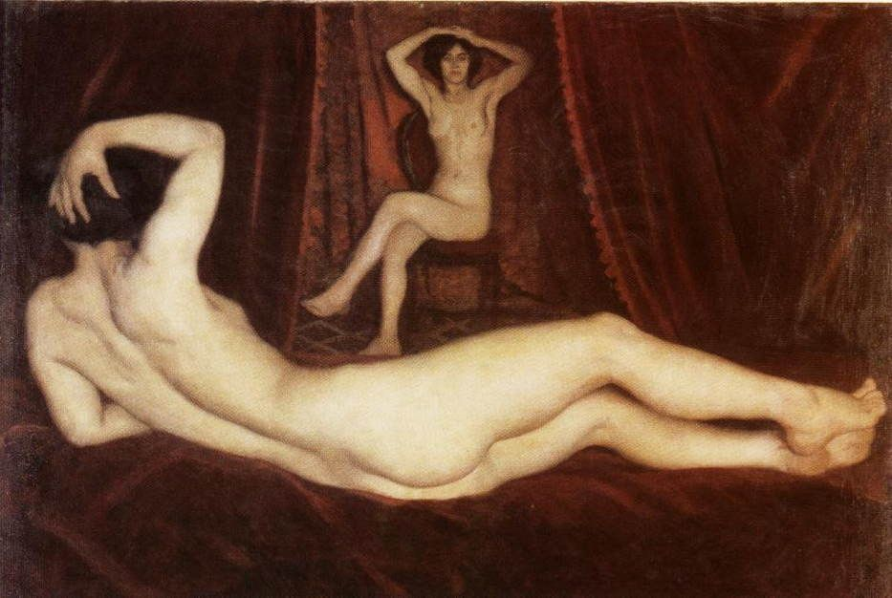
Painted fifteen years later, the peculiar painting, Gypsy Girl, acts to similar effect (Figure 4). It appears to depict two naked female artists’ models. One, turned away, lounges in the foreground on velveteen, taking up the pose of a traditional nude; the other, facing forwards, is seated in the background in the style of modernist nudes that acknowledge their artificiality, the starkness of the chair as the singular piece of furniture suggesting that it is part of an artist’s set. Considering the singularity of the title and the resemblance of the two forms, it may be that the two figures are that of the same young Gypsy model, abstracted to appear in two different positions in the painting. Accordingly, it is a layering of the Gypsy girl as nude model. The turning of the two figures towards one another creates the illusion of a distorted reflection that highlights the artifice of the image in front of the audience. Hence, Ferenczy stresses the construction of the Gypsy nude. The reappearance of this topic in Ferenczy’s work, in two compositionally and stylistically very different paintings completed at two different points in the artist’s career, suggests that the Gypsy girl posing as model was real and a common scene. By making overt the Gypsy girl as model, these later painters suggest that she was already established in Austro-Hungarian high culture as an eroticised object of external representation and thus instrumentalization. It is an acknowledgment of the artist’s male gaze.
Figure 4: Gypsy Girl, by Károly Ferenczy, 1916, oil on canvas, 95 x 140 cm, Budapest History Museum Municipal Gallery.

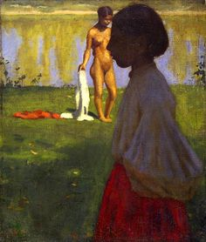
At first glance, it may seem that János Göröncsér Gundel’s painting, Gypsy Girl and Nude Model, dated to around 1907, is a counterexample in which the nude model stands in opposition to the Gypsy girl (Figure 5). Yet it is more likely that Göröncsér Gundel is, in a similar way to Ferenczy’s Gypsy Girl, playing with this convention of Gypsy girl as naked for male pleasure and use. Göröncsér Gundel presents his shapely, nude, female model in the background, with her clothes still in hand to suggest that she has only recently stripped. She exhibits the traits that we are accustomed to find together in the figure of the Gypsy girl: even if one is unconvinced by the idea of the Gypsy girl as a physically recognisable figure, the darker skin and hair suggests that she is the Romani representive. Thus, we would suppose that she is the Gypsy were it not for the painting’s title. This indicates that the ‘Gypsy girl’ is not the ‘nude model’, of whose identity the only clue is that she is not a Gypsy. The figure in the foreground of the painting, therefore, must be the Gypsy girl. Instead of being erotically exposed, she is obscured by both over-elaborate clothing and darkness (Éva Kovács goes so far as to call her a ‘silhouette’). Instead of being voluptuous, she is girlishly underdeveloped, connoting virginal innocence. The laboured means by which Göröncsér Gundel points out the toppling of these expectations – the disparity in the title between the identifying social and ethnic descriptor of Gypsy girl and the occuptional one of nude model, the darkened skin of the Gypsy girl – suggests that Göröncsér Gundel acknowledges the norm of Gypsy nude model.
Figure 5: Gypsy Girl and Nude Model, by János Göröncsér Gundel, c. 1907, oil on canvas, 69.5 x 59.5 cm, Hungarian National Gallery, Budapest.
The idea of the Gypsy girl as instrument for male, gadže consumption, is inherent in the prolific depiction of the Gypsy girl as a dancer or producer of music. Such representations reflect a wider corpus of cultural representations of the Gypsy as such an entertainer, including in the folk plays and operetta of the Dual Monarchy discussed by Lynn Hooker. The association of Romani with the character of the itinerant musician was likely caused by the combination of Romani nomadism and regulations imposed on the Romani as to what trades they could undertake. However, it was commonly believed that the Romani had a natural predisposition to these crafts. By the latter half of the nineteenth century, the reputation of Romani as excellent musicians, their rhythm resulting in a natural disposition to splendid dancing, was well established in Austria-Hungary. Whilst, as has already been explained, the violin is a motif throughout the depictions of Gypsies in these paintings, it is the tambourine with which the Gypsy girl is usually found.
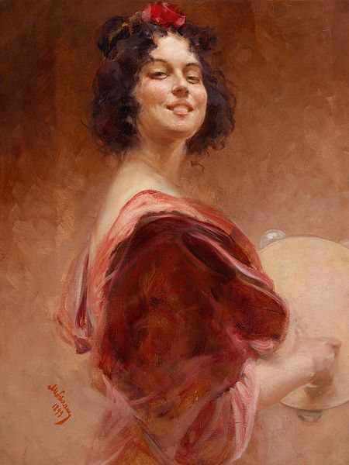
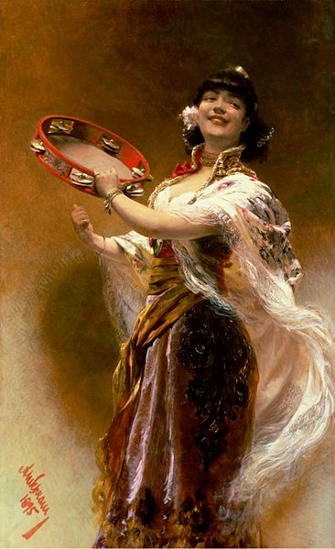
This is illustrated in two similar paintings by the Austrian artist Alois Hans Schram (1864-1919). Gypsy Girl with a Tambourine, painted in 1895, shows the by-now familiar character of the Gypsy girl (black hair, slim physique, plump lips, exposed forearms and chest) in an ornate costume of patterned skirt, dazzling headwear and collar, and long, embroidered shawl (Figure 6). This shawl billows away from the girl, indicating that she is in motion, which is likely linked to the final element of her costume, the large, bright tambourine which she holds. The suggestion is that she has been moving around to beat it, making her an adorned dancer, as well as a tambourine player. In addition, her red lips frame a smile. Altogether, she is exuberant. This exuberance is carried forth into Schram’s painting of four years later, Gypsy Woman with Tambourine (Figure 7). She is a much simpler figure, without the bodily ornamentation of her predecessor (excepting a headband) and without the momentum – though holding the tambourine that marks out her symbolic role as predisposed to move rhythmically. Instead, she is fixed in a smiling look outwards at the gadže spectator. She recognises the male gaze and smiles obligingly back. Ironically, this welcoming look makes her an easy figure for male consumption, just as the Romani musician and dancer tended to be.
Figure 7: Gypsy Woman with Tambourine, by Alois Hans Schram, 1899, oil on canvas, 64.5 x 50 cm, private collection.
Figure 6: Gypsy Girl with a Tambourine, by Alois Hans Schram, 1895, oil on canvas, dimensions unknown, private collection.
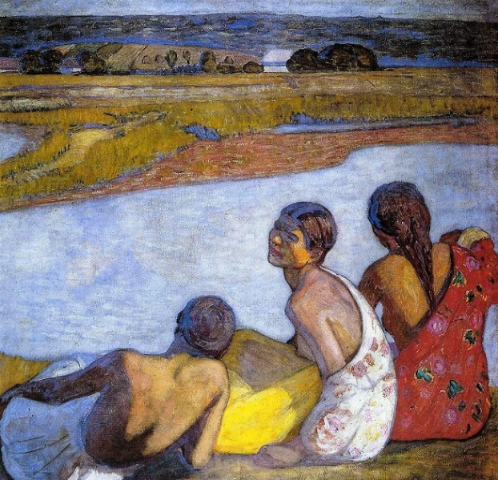
Having established the consistent imagination of Gypsy girls by Austro-Hungarian artists as objects of desire, it should be noted that a minority of artists deviated from this norm, all the while maintaining the traits that allow the recognition of the Gypsy girl subject. Perhaps the most notable example is the Hungarian painter Béla Iványi-Grünwald (1867-1940), who markedly departed from the model of beauty and celebrated sexual energy of the Gypsy girl character found in the works of Ferenczy. This is in spite of close ties between the two artists as friends and founding members of the Nagybánya artists’ colony, and consequent claims that Ferenczy’s work influenced Iványi-Grünwald’s. Iványi-Grünwald’s Gypsies are not traditionally attractive, as can be seen in Gypsy Girls by the Banks of the Lápos and Lányok a Vízparton [Girls by the Waterside] (Figures 8 and 9 respectively). Comparing Girls by the Waterside with Gypsy Girls by the Banks of the Lápos, believed to have been completed the previous year, indicates that the young women depicted in the latter painting are also Gypsies. In Iványi-Grünwald’s representation, the Gypsy girl loses her dainty features. This is especially evident in Girls by the Waterside, where the forward-facing girl displays protruding teeth with an apparent overbite, whilst a profile view enables her companion’s large, slightly hooked nose and overhanging brow to be seen. Moreover, both the forward-facing girl in Girls by the Waterside and her correlative in Gypsy Girls by the Banks of the Lápos have hunched shoulders that lack the elegance of other visual depictions of the Gypsy girl so far explored.
Figure 9: Lányok a Vízparton [Girls by the Waterside], by Béla Iványi-Grünwald, c. 1910, oil on cardboard,
67 x 73 cm, private collection.
Iványi-Grünwald’s portrayals of the Gypsy girl do retain, however, the character’s sexualisation. Three of the five Gypsy girls in these paintings have bare breasts, including the two front-facing figures who are the central subjects of these paintings. The side-on perspective foregrounds their large nipples. Combined with the apish features of the protagonist of Girls by the Waterside, this results in an appearance of bestial sexuality. The garish form of modernism to which Iványi-Grünwald subscribed enhances the brashness of the scene. Specifically, the Fauvist influence in these pieces, with its tendency towards bold brushwork and equally bold, bright colours, complements the rough vulgarity of these characters.
Figure 8: Gypsy Girls by the Banks of the Lápos, by Béla Iványi-Grünwald, 1909, oil on canvas, 115 x 115 cm, Maramures County Museum, Nagybánya.
The disparity between these two sets of images – those of the majority and those of Béla Iványi-Grünwald – prompts one to ask why this sexuality is depicted so negatively in the latter. Iványi-Grünwald’s depictions of the Gypsy girl are perhaps what one would at first expect to find, considering the suspicion and animosity with which Romani were generally treated in the Austro-Hungarian lands in the late nineteenth and early twentieth centuries. In a recent article, Tara Zahra convincingly details the discussion of a so-called ‘Gypsy question’ or ‘Gypsy nuisance’ in imperial Austria-Hungary that intensified as the nineteenth century progressed towards the twentieth. By 1908, a motion to combat the ‘Gypsy scourge’ was discussed in the Viennese Reichsrat and was met by rallying against Romani in the Austrian press. The very existence of a such a debate attests to the discomfort surrounding Romani in Austro-Hungarian society, partly a result of their perception as a drain on the localities in which they stayed, thieving from good Austro-Hungarian citizens.
A consistent characterisation in these complaints pitched Romani as not only alien but bestial. Indeed, Zahra quotes an essay published in 1898 in the Austrian newspaper, the Vorarlberger Volksblatt, which describes the end-point to attempted deportation of Romani from the Habsburg lands: ‘the result is always the same: the Gypsies come back, like insects that you believed had been exterminated’. As Zahra rightly points out, the essay likens Romani to ‘pests’. Elsewhere, they are labelled a plague or, in arguments that they drained common resources, parasites, constituting a trope of Romani as less-than-fully human. With this knowledge, Iványi-Grünwald’s brash depiction of the sexually available Gypsy girl takes on a more sinister meaning. The next section will discuss in more depth the racial construction of Gypsies, but for now it is important to emphasise the strong sentiments of anti-Gypsyism which Romani faced as a context to the production of these unlikely paintings.
The unease surrounding Romani in the Empire was matched by a heightened unease surrounding female sexuality in this period. The ‘Gypsy question’ was, in this way, matched by a more famous ‘woman question’ or Frauenfrage, in its German-language equivalent. These concerns arose from the increasing presence of women in public life, owing to the massification of culture, as well as in the gathering nature of urban workplaces, as Gábor Gyáni has shown. As well as the usual symbol of cinemas, Gyáni draws attention to the dance halls of Vienna and Budapest as bringing men and women closer physically in public than ever before and highlighting the sexual rhythms of this union. Women’s sexuality has historically been something simultaneously tantalising and in need of male control, as part of a patriarchal sytem. Even though the prospect of sexual liberation for women was hugely anachronistic, the germination of ideas of women’s liberation ignited fears and constituted a heightened awareness of female sexual potentiality. Whilst Ilona Sármány-Parsons has argued of the years up to 1905, that women were depicted in Hungarian painting in traditional forms, sheltered by Hungarian social conservatism from the rhetoric of the ‘New Woman’, an analysis of the hypersexualised Gypsy girl figure crafted by Hungarian painters amongst other nationalities within the Dual Monarchy suggests otherwise.
Competing ideas of gender are suggested in the simultaneous depiction of this figure as attractive by the overwhelming majority of the artists studied and more animalistic depictions that populate the works of Béla Iványi-Grünwald. The latter are more reflective of the wider disdain with which Romani were held in the imagination of Austro-Hungarian society, yet these coexist with the unremitting presentation of the Gypsy girl by Austro-Hungarian artists as a figure inhabiting a Romany pulchritude topos, constituting a tradition on which some artists made variations..

Race and Nation

The gender crises of the late nineteenth century onwards do not explain fully the sexual objectification of young Gypsy women in art; as well as being women, they were members of an ethnic group that was transformed in the imagination. The imperial and oriental gaze through which Romani, alongside various racial ‘others’, were viewed and represented will be communicated in this section.
In Romani culture, women are traditionally averse to public nudity and highly sexually conservative. Female modesty is enshrined in ritual purity codes under which, in the words of Angus Fraser,
The lower body, particularly of the woman, is considered marimé [‘unclean’ as used by Romani] and everything associated with it is potentially defiling – genitalia, bodily functions, clothing touching the lower body, and allusions to sex and pregnancy. […] Before puberty and after menopause, however, the prohibitions are fewer: a young girl may expose her legs by wearing short skirts; older women can associate more freely with men.

In this way, the adolescent women shown in these images would have been, in reality, the least exposed, physically and socially, of Romani women. Indeed, even the exposure of chest and breast, arms, and legs runs contrary to the reality of Romani as they would have been encountered by other inhabitants of the Dual Monarchy in real life. Another element of these ritual purity codes discourages Romani-gadže relations (in the process ironically pointing out the artifice of racial ‘cleanliness’ as a concept applied to any one group). One would think that this would impede the imagination of Romani girls as objects of desire by non-Romani men. The source, therefore, is at stark odds with the representation. The question follows of how such unlikely representations of oversexualised Romani girls came to proliferate the fine arts in this period.
The sexualisation of this figure is interesting not only for what it might say about women but what it might say about supposed foreigners, namely foreign women. By the mid- to late nineteenth century, schemata that associated standards of human civilisation with the mind and, conversely, standards of barbarity with the flesh were firmly established in Europe, in part building on a cultural legacy of mind-body dualism. In a culture that credited the plurality of races, the savage end of this scale often crossed into comparison with animal species, explaining the aforementioned likening of Romani to insects. Licentiousness, for its obvious relation to bodily functions, came to be viewed as in opposition to intelligent function and, consequently, as a marker of a more primitive state. Thus, the brazen sexuality which the Gypsy girl is shown as possessing in the artwork above, particularly in paintings by Valentiny or Iványi-Grünwald where the exposure of one bare breast seems to clash with polite society, is also a comment on the savagery of her ‘race’. In this regard, the Gypsy girl shares a great deal with stereotypes of the black African with his great fecundity but childlike mental simplicity and who, interestingly, was also famed as a rhythmic dancer, hinting at a supposed harmony with the body. This parallel corroborates the idea posed by the notion of the male gaze that the female Gypsy subject is reduced to her body. In this way, the sexualisation of the Gypsy girl as a Rom in particular derives from a broader and established values system that places it as a marker of savagery, rather than deriving from Romani cultural practices.
These ideas hardened in the latter half of the nineteenth century. Charles Darwin’s On the Origin of Species by Means of Natural Selection, or the Preservation of Favoured Races in the Struggle for Life, published in 1859 (with a German translation following as soon as 1860), showed the descent of life from a common ancestor. With The Descent of Man, and Selection in Relation to Sex, published twelve years later, Darwin took the stop of including humans in this moddel. According to Peter Bowler, the ideas contained in On the Origin of Species, at least, were widely accepted in the European scientific community by the 1870s. These developments seemed to legitimised a scalar and hierarchical conceptualisation of human life. What followed was the emergence of so-called scientific racism, seemingly supported by the developing discipline of anthropology, which would be used to classify Romani as ‘other’.
The especial interest of imperial states in particular in classifying human life has already been shown by historians, though most scholarship on this topic has focused on the external advancement of European imperial projects. The imperialism of Austria-Hungary, however, was Intereuropean. As a multinational state in which two groups – Germans and Hungarians – were grossly overrepresented, the majority of ethnic groups within the Dual Monarchy experienced a sense of internal colonisation, expressed in the historiographic tradition of Austria as a ‘prison of nations’ that Steven Beller observes. Among these groups, the Romani had no specific legally enshrined representation, with no Romani language made an official language of the Empire and no explicitly nationalist groups agitating for increased Romani political power. Edward Said, in his seminal work, Orientalism, has shown the commitment of colonial powers to cultivating a monopoly of knowledge of the people they have colonised as a way of exerting power over them. The documentation and definition of Romani by gadže in Austria-Hungary can be seen as part of this project, of which visually recording – even if not commissioned by the state – was one way of exerting power from a more dominant group onto a minority.
Efforts to document Romani, as Zahra has noted, included two ethnographic articles in a twenty-four volume encyclopaedia published between 1886 and 1902, The Austro-Hungarian Monarchy in Word and Image or Kronprinzenwerk. These exercises of anthropological power, bolstered by accompanying illustrations produced by Julius Zuber, authoritatively relay the dark features of the Romani, the slim build and ‘bronze’ skin. Both entries, according to Zahra, emphasise the physical traits of Romani in an act of ‘racial phenotyping’. The most definitive instance of the monitoring of Romani by Austro-Hungarian authorities was perhaps a census of the Romani population that was decreed in Hungary in 1893. It had a stated purpose of ‘transform[ing] the Gypsies into human, civilised, contented members of society, useful citizens of the state, true sons of the nation and of the Fatherland.’ Therefore, at times, these records of Romani were used purposefully to consolidate hegemonic control over them.
These acts of monitoring and recording Romani from the power of the imperial state share the same lens as depictions of Gypsy girls in the Empire’s art, this being an ‘imperial gaze’. Building on the work of Robert Stam and Louise Spence that had already demonstrated the gaze of the ‘First World’ upon the ‘Third World’, E. Ann Kaplan coined the term to denote ‘looking relations between colonizers and colonized’, predominantly referring to the observation of the colonised by the colonisers. For Kaplan (who, like Mulvey, was writing from a background of Film Studies), it was explicitly analogous to the male gaze and its power structures of spectatorship.
The gaze of imperial powers on Romani also converges with an Orientalist viewpoint, identified by Edward Said in his aforementioned book of the same name. ‘Orientalism’ is used by Said to denote cultural representations of ‘the East’ as an irrational, weak, feminized, and licentious Other. Like the censuses and encyclopaedic descriptions it warrants, it is a form of exerting power. Writing on perceptions of the Balkans, Milica Bakić-Hayden and Robert Hayden first devised the idea of ‘nesting orientalisms’ to suggest that the Orientalist iconography has been applied to those perceived as some degree as other beyond the bounds of an Arab ‘Near East’ and a Southeast Asian ‘Far East’ that traditionally demarcate the frame of analysis. This paradigm, however, is also geographically oriented, as it is defined as one ‘in which there exists a tendency for each region to view cultures and religions to the south and east of it as more conservative or primitive.’ The representations of Gypsies by gadže painters in the Habsburg lands during the late-nineteenth and early-twentieth centuries expose the limitations of this aspect of the model. Romani characters, characterised as historically nomadic, are also positioned on this spectrum of oriental-ness as a kind of ‘other within’. Their characteristic darkness epitomises this. Thus, the Gypsy girl can be understood with a revised, opened-up idea of nesting orientalism.
This may explain the interest of artists such as Alois Hans Schram in the Gypsy subject, which was highlighted in the previous chapter by the analysis of two of his paintings of female Gypsy tambourine players. While Schram did not depict the orientalist theme exclusively at this time, it is certainly a central preoccupation in his art. Hence, from paintings such as The Dice Players, in which hooded, turbaned, and tunicked dark-skinned men are playing dice in a dusty street, Schram may be labelled an orientalist painter. Indeed, during the 1890s Schram travelled to the ‘Near East’ to mature his study of orientalist subjects, completing works including Beauté Orientale [Oriental Beauty] (Figure 10). It was in this period of his artistic career that Schram completed his Gypsy girl paintings, themselves representing a form of oriental beauty. In doing this, he was perhaps informed by knowledge of the claim, widely known by this time, that the Romani had originated from the Eastern lands of India, and, even if not, certainly a sense of Gypsies as nesting orientals. Moreover, Schram’s paintings characteristically do not represent the lower strata of the Empire, the other major category that Gypsies might occupy for artists of this late Romance period which shall be discussed in the next section on modern life. Therefore, it seems that Gypsies, for Schram, despite their numeration in the Empire, had a level of foreign mystery which qualified them to have the attraction of the exotic.
Figure 10: Beauté Orientale [Oriental Beauty], by Alois Hans Schram, 1892, pastel on cardboard, 67 x 52 cm, private collection.
As the figure of the Oriental beauty might suggest, despite the narrowing down, describing, and defining of ethnic groups by the imperial state, analysis of the visual arts suggest that these categories often merge. The figure of the Gypsy girl shares many characteristics with other exotic females. The paralleling of Gypsy and Jew in both history and historiography, as fellow eastern outsiders within European cultures up to the Second World War, appears in artwork depicting young women. The shared trope of sexualisation is typified in the representation of Salome. A mythic, Jewish, femme fatale – the story tells of Salome demanding the head of John the Baptist from her step-father, Herod, and, upon dancing for him, received it – her image also proliferated during the anxieties about female sexual power and the other within. In this way, Paris-based Czech artist Alphonse Mucha’s (1860-1939) art nouveau Salomé shows a honey-skinned woman with cascading, ebony hair, in skimpy clothing (Figure 11). She even holds a circular instrument, bending backwards in the pose of a dancer appropriate for both Salome and the Gypsy girl. Unsurprisingly, she has been misidentified as a Gypsy. This is especially true online, suggesting widespread familiarity with this iconography of the female Gypsy.
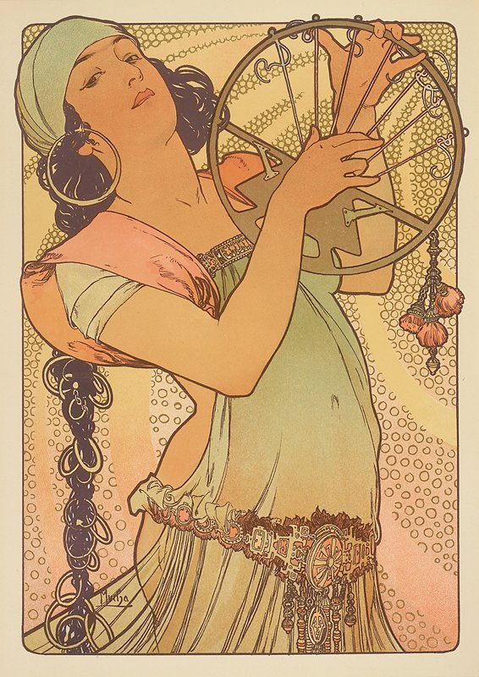
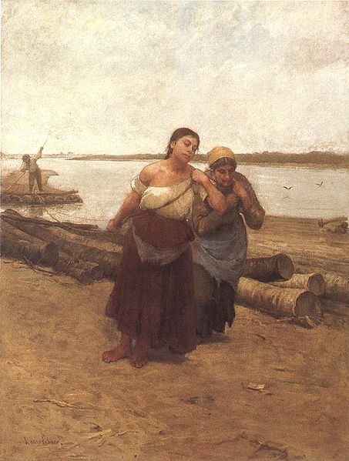
More strikingly, there are significant commonalities between depictions of Gypsy women by gadže artists and depictions of Hungarian peasant women by metropolitan artists. With black hair down her back, tanned skin revealed in an off-shoulder, off-white top, bare forearms and feet, a straight nose, and large eyes and mouth, the younger woman in Boat Warpers by Hungarian painter Lajos Deák-Ébner (1850-1934) meets the criteria laid out earlier for identifying a Gypsy girl in art (Figure 12). However, there are also indicators that she is a non-Romani Hungarian. One is her juxtaposition with a head-scarfed woman: Gypsy women, unlike Hungarian women in this period, are rarely depicted with their hair entirely covered and, as has already been established, scenes of gadže and Romani contact are uncommon and, when they do appear, fit predetermined types. Moreover, the painting lacks both an essentializing title and Gypsy clichés, with no cards, no tambourine or violin, and no animals. Where the woman principally differs from the image of the Gypsy girl so far presented is that she is not sexually enticing. Her mouth is oversized and her body bulky. She is not idealised. Her leant-forward stance and downturned mouth indicate the burden of her labour which, in combination with the dreary surroundings, suggests the bleakness of life for the Empire’s peasants. Ultimately, it is unclear whether she is intended to represent a Gypsy or a non-Gypsy Hungarian woman. Thus, the tropes present in the image of the Gypsy girl are employed to represent those who appeared primitive others to the artists that represented them (peasants included in this category), marked by racial othering in the darkening of the eyes, skin, and hair from the norm, and the exposure of flesh.
Figure 11: Salomé, by Alphonse Mucha, 1897, lithograph, 31 x 41 cm, private collection.
Figure 12: Boat Warpers, by Lajos Deák-Ébner, 1878, oil on canvas, 131.5 x 98 cm, Hungarian National Gallery, Budapest.
In this way, the depiction of the Gypsy girl is itself an act of Austria-Hungary’s imperial gaze. An orientalist gaze exposed supposed nesting orientals, including Romani, to these external representations and reiterated their association with a set of principles that was considered to be in opposition to those of European civilization. These principles included the libidinous, simple, and feminised nature of the oriental, hence explaining the proliferation of the image of the aesthetically appealing, erotic, and shallow Gypsy girl.
Modernity

Contrasting with the more faithful depictions of rural life by Deák-Ébner, a strong element of mainstream culture idealised the Gypsy lifestyle. This was portrayed as an uncorrupted way of life that was being lost as part of the nationalistic empire-building and modernising process. Reacting against the accelerating efforts in Austria-Hungary to contain ‘primitive’ Romani communities, This section will discuss how this conflict, an undoubted manifestation of the well-documented fin-de-siècle anxiety about modernisation, shows itself in the artistic depiction of Gypsy girls, exploring first those portrayed in rural scenes and then returning to the representation of virtuosity.
Industrialisation and urbanisation marked Austria-Hungary’s modernisation in the late nineteenth and early twentieth centuries. High economic growth was demonstrated in not only the displays of technological innovation at the world exhibitions of Vienna, 1873, and ‘Budapest at the Time of the Millennium’, 1886, but in urban expansion. Six years after the formation of the Dual Monarchy, the settlements of Buda and Pest were officially unified with the addition of Old Buda. Henceforth, it became known as the fastest-growing city in Europe (in reality, outstripped by only Christiania, modern-day Oslo). Similarly, in 1857, Vienna began to sprawl beyond its historic bounds of the old city walls. The decades of construction that followed prompted resident and writer Karl Kraus to claim in 1897, ‘Vienna is now being demolished into a big city’. Kraus’ words indicate the sense of loss that accompanied such rapid changes to the structure of society. As Steven Beller points out, some agricultural regions of the sprawling Empire remained untouched, but these were outstripped by the emergence of new urban centres. Cries that civilisation fed into decadence exacerbated anxieties about these vicissitudes.
The desire to supplant industrial urbanity with the countryside, in which could be found a preserved vision of the past, was expressed in the establishment of an artists’ colony in the small town of Nagybánya, northern Romania, in 1896. Led by Hungarian painter Simon Hollósy, the naturalist school of painters who founded the colony were previously based in Munich and included (as has already been noted) Károly Ferenczy and Béla Iványi-Grünwald as prominent members. Hollósy summarised the group’s ethos of finding national and artistic regeneration through a retreat into nature, saying, ‘only if nourished by the soil of our native land, only beneath a Hungarian sky and by renewed contact with the Hungarian people, can Hungarian art acquire strength, greatness and become genuinely Hungarian.’ The narrative of the Nagybánya school, along with the artwork produced there, illustrates the wider romanticist influence on the production of images of the Gypsy girl in this period.

Several scholars have explicated the links between romanticism and nationalism suggested by Hollósy. Prasenjit Duara has explained,
[National] authenticity is frequently embodied in living persons such as the child, the woman, the rustic, the aboriginal, and royalty. Each invokes symbolic affects in various historical cultures, including the association of timelessness with the royalty, innocence with children, naturalness with the primitive, rootedness with peasants, and motherhood or chastity with women.

Having already demonstrated the ‘hyperembodiment’ of young Gypsy women in the Austro-Hungarian imagination, thereby dispelling their claims to ‘chastity’, it is the association between ‘naturalness’ and ‘the primitive’ which is most compelling. Additionally, the understanding of Gypsies as wanderers rendered any association with the spatial ‘rootedness’ of peasants – essentially the disenfranchised, rural poor – inapplicable. Their association with a temporal ‘rootedness’, however, was demonstrated in the perception of Gypsies as unchanging. In this way, romanticism suggested that the real expression of the nation could only be found in those vanishing areas that were so far uncorrupted by the tendency towards modernisation. Gypsies, imagined as living beyond the bounds of civilised society, were the ultimate conceptualisation of this. In this way, Gypsy characters were often crafted as ‘noble savages’, whose primitive state of nature had kept them from corruption.
This zeitgeist was expressed in part through a pre-existing pastoral tradition. The longevity of the genre owes much to the universal anxiety of a lost golden age of innocence and harmonious relations between man and nature and one another. Indeed, the genre habitually shares the same retreat from the evils of court and city into the countryside that these largely metropolitan artists completed if not in reality, in the construction of a rural vision in their artwork.
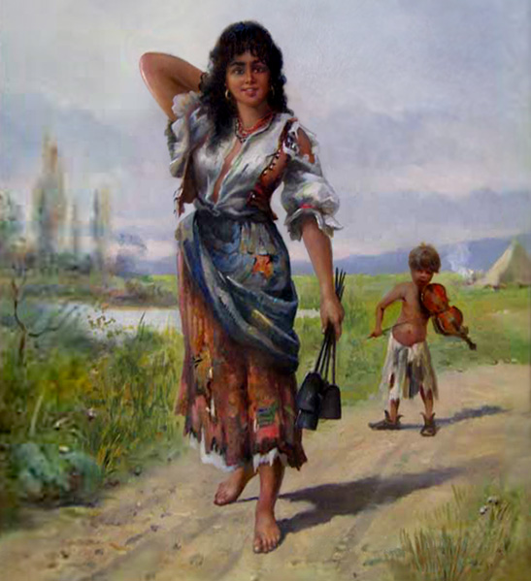
As such, the aestheticized and alluring Gypsy girl often exists in an idealised rural setting (the self-aware studio paintings previously discussed being a notable exception to this). A number of paintings by the Hungarian artist Kalman Borsodi exemplify this. In Gypsies and Gypsy Family in Landscape, a friendly-looking Gypsy girl occupies the foreground of a green and brown plain, the closest sign of the outside world’s intrusion the uneven dirt track that has emerged from the shrubbery (Figures 13 and 14). Mountains, tall trees, and, in Gypsies, a pond provide a symbolic shield from modern gadže civilisation. The signs of inhabitation also in the background of Gypsies are pre-industrial – a tent for shelter and a fire. It appears as if these Gypsies are ignorant of the luxuries of modern, electrified life.
Figure 13: Gypsies, by Kalman Borsodi, late nineteenth century, oil on canvas, dimensions unknown, private collection.

Figure 14: Gypsy Family in Landscape, by Kalman Borsodi, nineteenth century, oil on panel, 21 x 16 cm, private collection.
The Gypsy girl herself shows the trappings of a figure isolated from modern intervention. The cultural weight behind this depiction lies in the famous, centuries-long resistance of Romani to acculturation in Austria-Hungary. Failed assimilationist policies of Empress Maria Theresa and her son Joseph II in the late eighteenth century transformed in the nineteenth century into the Empire’s internal ‘civilizing mission’. In Hungary, this was marked out by Magyarization policies, propagating the awareness of Romani isolation from dominant culture. It is notable that the Gypsy girl in these paintings is dressed in the most shabby clothing – it is not even patched up – of all those included in this dissertation. Furthermore, both iterations of this character clutch instruments used in traditional homeware: the girl in Gypsies holds a set of fire shovels, whilst the girl in Gypsy Family in Landscape holds what appears to be a jug or a sack. Meanwhile, in her other hand, the girl in Gypsy Family in Landscape holds a dead capon, suggesting the Gypsy family’s immediacy to nature in the form of the animals they consume. Animals, dead and alive, are a common feature in scenes of bucolic Gypsy life. Dogs and horses are especially prevalent as emblems of the wandering lifestyle, particularly in the related tradition of Gypsy landscapes which do not focus on the figure of the Gypsy girl. Alongside a symbiosis with natural living, these paintings envisage social harmony. The Gypsy girl smiles down at a female child, who looks back at her in a posture of polite propriety. Similarly, a talented small boy plays the violin behind the smiling Gypsy girl protagonist in Gypsies, as if playing for her. Altogether, these paintings conjure an image of traditional, rural life as simple and idealistic, in spite of poverty. With the awareness that this mode of life was vanishing in the Habsburg lands (elsewhere it is pitched as the eradication of primitive, outsider cultures), this romanticised portrayal of Gypsy life becomes an expression of nostalgia. Moreover, the placement of this attractive archetype in a rustic setting posits the associated desirability within that past-connoting landscape.
The somewhat contradictory relationship that exists between Gypsy identity and Hungarian identity in music may be read in view of this Romantic vision of the pre-civilised rustic. The Gypsy reputation for virtuosity, as has already been discussed in the context of the female musician and dancer figure, was exploited in the proliferation of Gypsy styles in the Empire’s musical culture, including gadže forms such as operetta, from the nineteenth century into the early twentieth. In fact, the Hungarian style in music and Gypsy style in music were often conflated in a designation of ‘Hungarian-Gypsy style’. The surprising suggestion, articulated most famously by Hungary’s best-known composer, Franz Liszt, is that Hungarian folk culture can be located in the Gypsy style. In this way, the resurgence of the Gypsy style has also been seen as a nationalist expression of idealised Gypsies under the control of a broader Hungarian nation (and, more broadly, Austro-Hungarian Empire). Consequently, depictions of the female Gypsy performer in visual arts should also be viewed with an awareness of contemporary interpretations of Gypsies as a repository of national culture.
Thus, the Gypsy girl is aligned in the imagination with an idealistic mode of life epitomised in the rural and felt to be in dialectical opposition to modern, urban society. Her spiritual, if not sexual, innocence is restored in this way as her eroticism is transformed into an alternate vision of desirability for those alienated from nature. These depictions therefore indicate the existence of a positive interpretation of the notion that Gypsies were closer to nature than civilisation.

Conclusion

The representation of the Gypsy girl as an attractive and inviting beauty, rather than a new and unique individual in each depiction, forms a distinct and rich tradition in Austro-Hungarian fine art from the Compromise of 1867 until the Empire’s dissolution in 1918. Her depiction follows a Romany pulchritude topos of raven locks; big, dark eyes and full lips, all perfectly proportioned features; matched by a slender and well-proportioned body of tanned skin, scarcely covered by rags; and almost always revealing bare forearms, feet and neck, previously identified in literature by Nicholas Saul. The departure from the straightforward and overt societal stigmatisation of Romani (for the images in question are not disgusting and do not depict Romani criminality or idleness), indicates tensions in how the artistic elite of Austria-Hungary imagined Gypsies and what they were believed to represent at a time of great change in the way people thought about women, racial otherness, and modernisation.
At a time when male mastery first began to be challenged, it was reasserted by the imagining of the female Gypsy body as sexually desirable, thus reclaiming it for the male artist. Similarly, as other areas of hegemonic political and cultural life sought to exert control over racial others, including the eastern minorities of the Empire, paintings of the Gypsy girl demonstrate the capacity of gadže power to represent Romani regardless of reality. In these instances, these representations are a way of re-exerting traditional power systems. Equally, the sexual allure with which these women are depicted is a legacy of the association of corporeality and ‘bestial’ lasciviousness with others and, in particular in this period, eastern others. This categorisation of the Gypsy girl alludes to the blurring of representative characteristics between Gypsy women and other ‘others’, suggesting the extent to which depictions of Romani have been influenced by ideological rather than observational factors. Gypsy girls in this way are depicted with a resemblance to peasant girls, aligning the Gypsy lifestyle with a folk lifestyle. Accordingly, many images of Gypsy girls situate her in a context of social and ecological harmony, believed to be found in a vanishing pastoral landscape. These images appear to emerge from anxieties about the forces of industrialisation and urbanisation that were transforming the Habsburg lands. In paintings of this kind, the desirability of the Gypsy girl subject extends beyond her sexual availability and attractiveness to the symbolic appeal of her primitiveness, once again suggesting the conflicting attitude of large portions of the Austro-Hungarian populace towards modernisation.
Thus, the male gaze is an inadequate concept to alone explain the sexualisation of the Gypsy girl; there are also imperial, oriental, and nostalgic gazes that, as a result of subjugated Romani status in Europe, converge on this figure, necessitating an interdisciplinary analytical approach to this history. Therefore, gendered, racial or national, and romanticist interpretations of the character are not competing but combined ones.
This is not to reduce Romani History to that of the nations which Romani inhabited, but rather to integrate the two narratives in a way that has so far been limited. In the process, a more complete idea of the conceptualisations of Austro-Hungarians relating to young Romani women and all they represented can be gained. Moreover, this approach allows us to dissect an inherited Romani iconography with a knowledge of the societies in which images were produced and reproduced and thereby historicize these images. Stereotypes of the sexually desirable and available Gypsy girl persist in present-day Europe, if in a form that has evolved with the changing tensions of our growing society, making it all the more important to reveal the external construction of this prejudice historically.
Areas for further study are almost always profuse in any monograph on Romani History. Specifically, however, to understand how far the character of the Austro-Hungarian Gypsy girl is a unique one, comparative studies assessing the position of this iconography within a wider European narrative are necessary. Examining the French Esmerelda or the Spanish gitana theme alongside the central European Gypsy girl would be further illustrative of the extent to which nationally-specific factors influence the construction of these characters. Similarly, studies of other Gypsy archetypes or motifs – the Gypsy boy with a fiddle, or the Gypsy landscape, perhaps – in visual art would a welcome development on Bencsik’s survey of the Hungarian iconography. Such endeavours would help in the outstanding task of filling the vast gaps in academic Romani History.

Bibliography:
Primary Sources:
Visual Material on the Image of the Gypsy Girl:
Borsodi, K., Gypsies, late nineteenth century, oil on canvas, dimensions unknown, private collection
— Gypsy Family in Landscape, nineteenth century, oil on panel, 21 x 16 cm, private collection
Ferenczy, K., Gypsies, 1901, oil on canvas, 122 x 122 cm, Hungarian National Gallery, Budapest
— Gypsy Girl, 1916, oil on canvas, 95 x 140 cm, Budapest History Museum Municipal Gallery
Göröncsér Gundel, J., Gypsy Girl and Nude Model, c. 1907, oil on canvas, 69.5 x 59.5 cm, Hungarian National Gallery, Budapest
Iványi-Grünwald, B., Gypsy Girls by the Banks of the Lápos, 1909, oil on canvas, 115 x 115 cm, Maramures County Museum, Nagybánya
— Lányok a Vízparton [Girls by the Waterside], c. 1910, oil on cardboard, 67 x 73 cm, private collection
Schram, A. H., Gypsy Girl with a Tambourine, 1895, oil on canvas, dimensions unknown, private collection
— Gypsy Woman with Tambourine, 1899, oil on canvas, 64.5 x 50 cm, private collection
Valentiny, J., Fortune Teller, n.d., oil on canvas, 80 cm high x 64 cm wide, private collection
— A Kedvenc Nóta [My Favourite Song], n.d., oil on canvas, 130.5 x 164 cm, private collection

Additional Visual Material:
Deák-Ébner, L., Boat Warpers, 1878, oil on canvas, 131.5 x 98 cm, Hungarian National Gallery, Budapest
— Melon Market, n.d., oil on canvas, 48 x 71 cm, private collection
Mucha, A., Salomé, 1897, lithograph, 31 x 41 cm, private collection
Munkácsy, M., Cigány Család [Gypsy Family], n.d., oil on canvas, 115 x 145 cm, private collection
Schram, A. H., Beauté Orientale [Oriental Beauty], 1892, pastel on cardboard, 67 x 52 cm, private collection
— The Dice Players, 1887, oil on panel, 25 x 55.5 cm, private collection
Valentiny, J., Gypsy School, 1896, oil on canvas, dimensions unknown, Hungarian National Gallery, Budapest
— Itáliai Lány a Tengerparton [Italian Girl on the Beach], n.d., oil on canvas, 140 x 97 cm, private collection
— Olasz Tengerparton [Italian Beach], 1875, oil on canvas, 59 x 84.5 cm, private collection
Vastagh, G., A Kárvallott Cigány [The Unfortunate Gypsies], oil on canvas, 127 x 169.5 cm, private collection

Printed Material:
Darwin, C., The Descent of Man, and Selection in Relation to Sex (London: John Murray, 1971)
— On the Origin of Species by Means of Natural Selection, or the Preservation of Favoured Races in the Struggle for Life (London: John Murray, 1859)
Liszt, F., Des Bohémiens et de leur Musique en Hongrie (Paris: Librairie Nouvelle, 1859)

Online Sources:
‘Alphonse Mucha, Salome, Gypsy, Dance Girl, Fashion, Boho Style Art Print, Bohemian Decor, 11x14" Cotton Canvas Print, Art Deco’, Etsy, <www.etsy.com>, last accessed 4 March 2019
‘Mucha, Alphonse – EM08a – Salome’, Yaneff, <www.yaneff.com>, last accessed 4 March 2019

Secondary Sources:
Romani in the Austro-Hungarian Empire:
Barany, Z., ‘The East European Gypsies in the Imperial Age’, Ethnic and Racial Studies 24:1 (2001), pp. 50-63
Bencsik, G., Hungarian Gypsy Picture Book: The Historic Iconology of the Gypsies in Hungary, 1686–1914 (Budapest: Magyar Mercurius, 2013)
— ‘Image and Picture: The Romani People Theses to the Historical Iconology of the Hungarian Gypsies’ (2013), <kethanodrom.hu>, last accessed 13 March 2019
Crowe, D. M., ‘From Persecution to Pragmatism: The Habsburg Roma in the Eighteenth Century’, Austrian History Yearbook 37 (2006), pp. 99-120
— and Kolsti, J., eds., The Gypsies of Eastern Europe (Armonk, NY, and London: M. E. Sharpe, 1991)
Davis, S. D., ‘Competitive Civilizing Missions: Hungarian Germans, Modernization, and Ethnographic Descriptions of the Zigeuner before World War I’, Central European History 50:1 (2017), pp. 6–33
Dzambazovic, R., ‘The Romany in Hungary at the End of the 19th Century’, Sociologia 33:5 (2001), pp. 491-506
Hooker, L., Redefining Hungarian Music from Liszt to Bartók (Oxford: Oxford University Press, 2013)
— ‘Turks, Hungarians, and Gypsies on Stage: Exoticism and Auto-Exoticism in Opera and Operetta’, Hungarian Studies: A Journal of the International Association for Hungarian Studies and Balassi Institute 27:2 (2013), pp. 291-311
Johnson, E., ‘Counting and Categorizing: The Gypsy Census in the Kingdom of Hungary, 1893’, Journal of the Gypsy Lore Society 8:2 (1998), pp. 83–115
Kovács, É., ‘Fekete Testek, Feher Tesket’ [Black Bodies, White Bodies], Beszélő Online 14:1 (2009)
Loya, S., Liszt's Transcultural Modernism and the Hungarian-Gypsy Tradition (Rochester, NY: University of Rochester Press, 2011)
Veszprémi, N., ‘Stereotypes and What They Hide: On the Representation of Gypsies in Hungarian Painting’, Hungarian Art History, 31 January 2013, <hungarianarthist.wordpress.com>, last accessed 10 January 2019
Zahra, T., ‘“Condemned to Rootlessness and Unable to Budge”: Roma, Migration Panics, and Internment in the Habsburg Empire’, American Historical Review (2017), pp. 702-26

History of the Romani:
Crowe, D. M., A History of the Gypsies of Eastern Europe and Russia (London: I.B. Tauris, 1995)
Clark, C., ‘‘Severity Has Often Enraged but Never Subdued a Gipsy’: The History and Making of European Romani Stereotypes’, in N. Saul and S. Tebbutt, eds., The Role of the Romanies: Images and Counter-Images of ‘Gypsies’/Romanies in European Cultures (Liverpool: Liverpool University Press, 2004), pp. 226-46
Dearing, S., ‘Painting the Other Within: Gypsies According to the Bohemian Artist in the Nineteenth and Early Twentieth Centuries’, Romani Studies 20:2 (2010), pp. 161-201
Fraser, A., The Gypsies (Oxford: Blackwell, 1992)
Houghton-Walker, S., Representations of the Gypsy in the Romantic Period (Oxford: Oxford University Press, 2014)
Lewy, G., Gypsies and Jews under the Nazis (Oxford: Oxford University Press, 1999)
Liégeois, J. P., Gypsies: An Illustrated History (London: Al Saqi Books, 1986)
Lutz, B. D., and J. M. Lutz, Gypsies as Victims of the Holocaust (Oxford: Oxford University Press, 1995)
Nord, D. E., Gypsies & the British Imagination, 1807-1930 (New York: Columbia University Press, 2006)
Saul, N., Gypsies and Orientalism in German Literature and Anthropology of the Long Nineteenth Century (London: Legenda, 2007)
Tebbutt, S., ‘Disproportional Representation: Romanies and European Art’, in N. Saul and S. Tebbutt, eds., The Role of the Romanies: Images and Counter-Images of ‘Gypsies’/Romanies in European Cultures (Liverpool: Liverpool University Press, 2004), pp. 159-77
Willems, W., In Search of the True Gypsy: From Enlightenment to Final Solution (London and Portland: Frank Cass, 1997)

General Habsburg History:
Beller, S., The Habsburg Monarchy, 1815-1918 (Cambridge: Cambridge University Press, 2018)
Deák, I., Beyond Nationalism: A Social and Political History of the Habsburg Officer Corps, 1848-1918 (New York and Oxford: Oxford University Press, 1990)
Judson, P. M., The Habsburg Empire: A New History (Cambridge, MA: Harvard University Press, 2016)
Schwartz, A. and H. Thorson, Shaking the Empire, Shaking Patriarchy: The Growth of a Feminist Consciousness Across the Austro-Hungarian Monarchy (Riverside, CA: Ariadne Press, 2014)

History of Austria:
Berg, B., ‘Nature and Environment in Nineteenth-Century Austrian Literature’ (doctoral thesis, Washington University in St. Louis, 2009)
Chew, G., ‘The Austrian Pastorella and the Stylus Rusticanus: Comic and Pastoral Elements in Austrian Music, 1750-1800’, in Music in Eighteenth-Century Austria, ed. D. W. Jones (Cambridge: Cambridge University Press, 1996), pp. 133-96
Hamman, B., Hitler’s Vienna: A Dictator's Apprenticeship (New York: Oxford University Press, 1999)
Judson, P. M., ‘The Gendered Politics of German Nationalism in Austria, 1880-1900’, in Austrian Women in the Nineteenth and Twentieth Centuries: Cross-Disciplinary Perspectives, eds. D. Good, M. Grandner, and M. Maynes (Providence, RI, and Oxford: Berghahn Books, 1996), pp. 1-17
Schorske, C. E., Fin-De-Siècle Vienna: Politics and Culture (New York: Vintage Books, 1981)
History of Hungary:
Barenscott, D., ‘Articulating Identity through the Technological Rearticulation of Space: The Hungarian Millennial Exhibition as World's Fair and the Disordering of Fin-de-Siècle Budapest’, Slavic Review 69:3 (2010), pp. 571-90
Gyáni, G., Identity and the Urban Experience: Fin-de-Siècle Budapest (Wayne: The Center for Hungarian Studies and Publication, 2004)
Lukacs, J., Budapest 1900: A Historical Portrait of a City and Its Culture (London: Weidenfeld & Nicolson, 1989)

Fin de Siècle Europe:
Bowler, P., Evolution: The History of an Idea, 3rd edn (Berkeley and Los Angeles: University of California Press, 2003), pp. 177-80
Crook, P., ‘Social Darwinism and British “New Imperialism”: Second Thoughts’, The European Legacy 3:1 (1998), pp. 1-16
Hargreaves, J. D., ‘Towards a History of the Partition of Africa’, The Journal of African History 1:1 (1960), pp. 97-109
Harrington, A., ‘A Feeling for the ‘Whole’: The Holistic Reaction in Neurology from the Fin de Siècle to the Interwar Years’, in Fin de Siècle and Its Legacy, eds. M. Teich and R. Porter (Cambridge: University of Cambridge Press, 1990), pp. 254-77
Marshall, G., ed., The Cambridge Companion to the Fin de Siècle (Cambridge: University of Cambridge Press, 2007)
Art in the Fin de Siècle:
‘Альбом ‘Кочующий Скрипач’ [Album ‘Wandering Violinist’], Live Internet, 30 January 2012, <www.liveinternet.ru>, last accessed 12 January 2019
‘Alois Hans Schram’, Wien Geschichte Wiki, <www.geschichtewiki.wien.gv.at>, last accessed 26 February 2019
‘Béla Iványi Grünwald’, Encyclopedia Britannica, <www.britannica.com>, last accessed 24 February 2019
Gaillard, F., and C. Windish, ‘Naked, but Hairy: Women and Misogyny in Fin de Siècle Representations’, South Central Review 29:3 (2012), pp. 163-76
Howard, J., Art Nouveau: International and National Styles in Europe (Manchester and New York: Manchester University Press, 1996)
Krasznai, E., ‘Colloque: ‘Mythe, Fortune et Infortune de la Bohème’’ [Symposium: ‘Myth, Fortune and Misfortune of Bohemia’], 2 December 2012, <blog.apahau.org>, last accessed 1 February 2019
Entry for ‘Salomé, 1897’, Minneapolis Institute of Art, <new.artsmia.org>, last accessed 3 March 2019
Sármány-Parsons, I., ‘The Image of Women in Painting: Clichés and Reality in Austria-Hungary, 1895-1905’, in Rethinking Vienna 1900, ed. S. Beller (New York and Oxford: Berghahn Books, 2001), pp. 220-63
‘Schram, Alois Hans’, in Dictionary of German Biography: Volume 9: Schmidt - Theyer, eds. W. Killy et al. (Munich: K. G. Saur Verlag GmbH, 2005), p. 130
‘Schram, Alois Hans (1864-1919), Maler’, Institut für Neuzeit- und Zeitgeschichtsforschung Österreichisches Biographisches Lexikon, <www.biographien.ac.at>, last accessed 26 February 2019

Theory:
Bakić-Hayden, M., ‘Nesting Orientalisms: The Case of Former Yugoslavia’, Slavic Review 54:4 (1995), pp. 917-31
— and Hayden, R. M., ‘Orientalist Variations on the Theme “Balkans”: Symbolic Geography in Recent Yugoslav Cultural Politics’, Slavic Review 51:1 (1992), pp. 1-15
Burke, E. III and D. Prochaska, eds., Genealogies of Orientalism: History, Theory, Politics (London and Lincoln, NE: University of Nebraska Press, 2008)
Duara, P., Sovereignty and Authenticity: Manchukuo and the East Asian Modern (Lanham, MD: Rowman and Littlefield, 2003)
Garrard, G., Ecocriticism (London: Routledge, 2004)
Kaplan, E. A., Looking for the Other: Feminism, Film and the Imperial Gaze (London: Routledge, 1997)
Mulvey, L., ‘Visual Cinema and Narrative Pleasure’, Screen 16:3 (1975), pp. 6-18
Nederveen Pieterse, J., White on Black: Images of Africa and Blacks in Western Popular Culture (New Haven and London: Yale University Press, 1992)
Rehling, N., Extra-Ordinary Men: White Heterosexual Masculinity in Contemporary Popular Culture (Lanham, MD, and Plymouth: Lexington Books, 2009)
Said, E. W., Orientalism (London: Penguin, 2003)
Stam, R., and L. Spence, ‘Colonialism, Racism and Representation: An Introduction by Robert Stam and Louise Spence’, Screen 24:2 (1983), pp. 2-20

D. M. Crowe, ‘From Persecution to Pragmatism: The Habsburg Roma in the Eighteenth Century’, Austrian History Yearbook 37 (2006), p. 99.
The literal documentation of ethnic groups (or ‘nationalities’) by the Austro-Hungary Empire for ethnographic and other purposes will be discussed in the ‘Race and Nation’ section of this dissertation.
Willems, In Search of the True Gypsy, pp. 6-7.
S. Beller, The Habsburg Monarchy, 1815-1918 (Cambridge: Cambridge University Press, 2018), p. 280.
P. M. Judson, The Habsburg Empire: A New History (Cambridge, MA: Harvard University Press, 2016), pp. 328, 410, 525, note 76. The Hungarian census of the Romani population in 1893 estimated 274,000 in the kingdom. Zahra, ‘“Condemned to Rootlessness’”, p. 708.
G. Bencsik, Hungarian Gypsy Picture Book: The Historic Iconology of the Gypsies in Hungary, 1686–1914 (Budapest: Magyar Mercurius, 2013).
This wording is taken from an accompanying text to the book. G. Bencsik, ‘Image and Picture: The Romani People Theses to the Historical Iconology of the Hungarian Gypsies’ (2013), <kethanodrom.hu>, last accessed 13 March 2019, pp. 35-36. N. Saul, Gypsies and Orientalism in German Literature and Anthropology of the Long Nineteenth Century (London: Legenda, 2007), p. 160.
D. E. Nord, Gypsies & the British Imagination, 1807-1930 (New York: Columbia University Press, 2006). S. Dearing, ‘Painting the Other Within: Gypsies According to the Bohemian Artist in the Nineteenth and Early Twentieth Centuries’, Romani Studies 20:2 (2010), pp. 161-201. S. Houghton-Walker, Representations of the Gypsy in the Romantic Period (Oxford: Oxford University Press, 2014).
L. Hooker, ‘Turks, Hungarians, and Gypsies on Stage: Exoticism and Auto-Exoticism in Opera and Operetta’, Hungarian Studies: A Journal of the International Association for Hungarian Studies and Balassi Institute 27:2 (2013), pp. 291-311. L. Hooker, Redefining Hungarian Music from Liszt to Bartók (Oxford: Oxford University Press, 2013).
D. Crowe and J. Kolsti, eds., The Gypsies of Eastern Europe (Armonk, NY, and London: M. E. Sharpe, 1991), p. 6.
Willems, In Search of the True Gypsy, pp. 4, 5.
G. Garrard, Ecocriticism (London: Routledge, 2004), pp. 172-75.
G. Marshall, ed., The Cambridge Companion to the Fin de Siècle (Cambridge: University of Cambridge Press, 2007), pp. 6-7.
J. Valentiny, Fortune Teller, n.d., oil on canvas, 80 cm high x 64 cm wide, private collection. J. Valentiny, A Kedvenc Nóta [My Favourite Song], n.d., oil on canvas, 130.5 x 164 cm, private collection.
L. Mulvey, ‘Visual Cinema and Narrative Pleasure’, Screen 16:3 (1975), pp. 6-18. K. Ferenczy, Gypsies, 1901, oil on canvas, 122 x 122 cm, Hungarian National Gallery, Budapest. K. Ferenczy, Gypsy Girl, 1916, oil on canvas, 95 x 140 cm, Budapest History Museum Municipal Gallery. J. Göröncsér Gundel, Gypsy Girl and Nude Model, c. 1907, oil on canvas, 69.5 x 59.5 cm, Hungarian National Gallery, Budapest.
A. H. Schram, Gypsy Girl with a Tambourine, 1895, oil on canvas, dimensions unknown, private collection. A. H. Schram, Gypsy Woman with Tambourine, 1899, oil on canvas, 64.5 x 50 cm, private collection.
Z. Barany, ‘The East European Gypsies in the Imperial Age’, Ethnic and Racial Studies 24:1 (2001), p. 55.
B. Iványi-Grünwald, Gypsy Girls by the Banks of the Lápos, 1909, oil on canvas, 115 x 115 cm, Maramures County Museum, Nagybánya. B. Iványi-Grünwald, Lányok a Vízparton [Girls by the Waterside], c. 1910, oil on cardboard, 67 x 73 cm, private collection.
Dearing, ‘Painting the Other Within’, p. 167. E. Burke III and D. Prochaska, eds., Genealogies of Orientalism: History, Theory, Politics (London and Lincoln, NE: University of Nebraska Press, 2008), p. 209, note 16.
E. A. Kaplan, Looking for the Other: Feminism, Film and the Imperial Gaze (London: Routledge, 1997).
Dearing, ‘Painting the Other Within’, pp. 161, 163.
K. Borsodi, Gypsies, late nineteenth century, oil on canvas, dimensions unknown, private collection. K. Borsodi, Gypsy Family in Landscape, nineteenth century, oil on panel, 21 x 16 cm, private collection.
F. Gaillard and C. Windish, ‘Naked, but Hairy: Women and Misogyny in Fin de Siècle Representations’, South Central Review 29:3 (2012), pp. 167-70.
N. Saul, Gypsies and Orientalism, p. 54.
Dearing, ‘Painting the Other Within’, p. 185. Gaillard and Windish, ‘Naked, but Hairy’, pp. 164, 174.
Titles have been used in their original language where known. For a description of the fortune teller figure in art, see S. Tebbutt, ‘Disproportional Representation: Romanies and European Art’, in N. Saul and S. Tebbutt, eds., The Role of the Romanies: Images and Counter-Images of ‘Gypsies’/Romanies in European Cultures (Liverpool: Liverpool University Press, 2004), pp. 161-63. Valentiny, Fortune Teller.
All translations are my own. Valentiny, My Favourite Song. For Valentiny’s Italian beach scenes, see J. Valentiny, Itáliai Lány a Tengerparton [Italian Girl on the Beach], n.d., oil on canvas, 140 x 97 cm, private collection. J. Valentiny, Olasz Tengerparton [Italian Beach], 1875, oil on canvas, 59 x 84.5 cm, private collection.
J. Valentiny, Gypsy School, 1896, oil on canvas, dimensions unknown, Hungarian National Gallery, Budapest.
On scenes of Gypsy crimes, see Tebbutt, ‘Disproportional Representation’, p. 162.
On the virtue of the nude in fine art, see Gaillard and Windish, ‘Naked, but Hairy’, pp. 163, 165. C. Clark, ‘‘Severity Has Often Enraged but Never Subdued a Gipsy’: The History and Making of European Romani Stereotypes’, in Saul and Tebbutt, The Role of the Romanies, p. 234.
Schwartz and Thorson demonstrate male structural power in the Dual Monarchy in A. Schwartz, and H. Thorson, Shaking the Empire, Shaking Patriarchy: The Growth of a Feminist Consciousness Across the Austro-Hungarian Monarchy (Riverside, CA: Ariadne Press, 2014). Mulvey, ‘Visual Cinema’, pp. 6, 11, 12, 14.
Ibid., p. 11.
Ferenczy, Gypsies, cited in N. Veszprémi, ‘Stereotypes and What They Hide: On the Representation of Gypsies in Hungarian Painting’, Hungarian Art History, 31 January 2013, <hungarianarthist.wordpress.com>, last accessed 10 January 2019.
Ferenczy, Gypsy Girl.
Göröncsér Gundel, Gypsy Girl and Nude Model.
É. Kovács, ‘Fekete Testek, Feher Tesket’ [Black Bodies, White Bodies], Beszélő Online 14:1 (2009).
For example, the Gypsy violinist, Mujkó, in Hungarian composer’s Jenõ Huszka’s 1905 operetta, Gül Baba. Hooker, ‘Turks, Hungarians, and Gypsies’, pp. 301-304.
Barany, ‘The East European Gypsies’, p. 55.
Saul, Gypsies and Orientalism, pp. 3, 6.
‘Альбом ‘Кочующий Скрипач’ [Album ‘Wandering Violinist’], Live Internet, 30 January 2012, <www.liveinternet.ru>, last accessed 12 January 2019.
Schram, Gypsy Girl with a Tambourine.
Schram, Gypsy Woman with Tambourine.
For the role of Ferenczy and Iványi-Grünwald in the founding of the Nagybánya artists’ colony, see J. Howard, Art Nouveau: International and National Styles in Europe (Manchester and New York: Manchester University Press, 1996), p. 104. On the relationship between Ferenczy and Iványi-Grünwald, see ‘Béla Iványi Grünwald’, Encyclopedia Britannica, <www.britannica.com>, last accessed 24 February 2019.
Iványi-Grünwald, Gypsy Girls by the Banks of the Lápos. Iványi-Grünwald, Girls by the Waterside.
J. Lukacs, Budapest 1900: A Historical Portrait of a City and Its Culture (London: Weidenfeld & Nicolson, 1989), p. 172.
Zahra, ‘“Condemned to Rootlessness”’, pp. 703-25.
B. Hamman, Hitler's Vienna: A Dictator's Apprenticeship (New York: Oxford University Press, 1999), pp. 116-31.
Ibid., p. 704.
‘Die Zigeuner’, Vorarlberger Volksblatt, June 15, 1898, p. 1, cited in Zahra, ‘“Condemned to Rootlessness”’, p. 721.
Ibid.
H. Högel, ‘Die Zigeunerplage’, Österreichische Zeitschrift für Verwaltung, 9 August 1894, p. 1, cited in Zahra, ‘“Condemned to Rootlessness”’, pp. 712-13.
P. M. Judson, ‘The Gendered Politics of German Nationalism in Austria, 1880-1900’, in Austrian Women in the Nineteenth and Twentieth Centuries: Cross-Disciplinary Perspectives, eds. D. Good, M. Grandner, and M. Maynes (Providence, RI, and Oxford: Berghahn Books, 1996), p. 8.
G. Gyáni, Identity and the Urban Experience: Fin-de-Siècle Budapest (Wayne: The Center for Hungarian Studies and Publication, 2004), pp. 55-56.
Ibid.
I. Sármány-Parsons, ‘The Image of Women in Painting: Clichés and Reality in Austria-Hungary, 1895-1905’, in Rethinking Vienna 1900, ed. S. Beller (New York and Oxford: Berghahn Books, 2001), p. 228.
Saul, Gypsies and Orientalism, p. 160.
Fraser, The Gypsies, p. 245.
Ibid., pp. 244-45.
Crowe and Kolsti, The Gypsies of Eastern Europe, pp. 5-6.
N. Rehling, Extra-Ordinary Men: White Heterosexual Masculinity in Contemporary Popular Culture (Lanham, MD, and Plymouth: Lexington Books, 2009), p. 92.
The Mandingo stock character encompasses the supposed sexual insatiability of the black man., whilst the ideas of black dumbness and black propensity of dance is reflected in the ‘Sambo’ stock character. J. Nederveen Pieterse, White on Black: Images of Africa and Blacks in Western Popular Culture (New Haven and London: Yale University Press, 1992), pp. 152-53, 175.
C. Darwin, On the Origin of Species by Means of Natural Selection, or the Preservation of Favoured Races in the Struggle for Life (London: John Murray, 1859).
C. Darwin, The Descent of Man, and Selection in Relation to Sex (London: John Murray, 1971).
P. Bowler, Evolution: The History of an Idea, 3rd edn (Berkeley and Los Angeles: University of California Press, 2003), pp. 177-80.
P. Crook, ‘Social Darwinism and British “New Imperialism”: Second Thoughts’, The European Legacy 3:1 (1998), pp. 1-16. J. D. Hargreaves, ‘Towards a History of the Partition of Africa’, The Journal of African History 1:1 (1960), p. 108.
Beller, The Habsburg Monarchy, pp. 15-20.
Zahra, ‘“Condemned to Rootlessness”’, pp. 709-10.
E. W. Said, Orientalism (London: Penguin, 2003), pp. 6-7, 27, 36.
D. Dan, ‘Die Zigeuner’, in Die Österreichisch-Ungarische Monarchie in Wort und Bild: Volume 20: Bukowina (Vienna: K.K. Hof- und Staatsdruckerei, 1899), pp. 330–38. J. A. von Österreich, ‘Die Zigeuner’, in Die Österreichisch-Ungarische Monarchie in Wort und Bild: Volume 23: Ungarn (Vienna: K.K. Hof- und Staatsdruckerei, 1902), pp. 565–74, both cited in Zahra, ‘“Condemned to Rootlessness”’, p. 711.
Ibid., pp. 711-15.
Ibid., p. 711.
‘Die Ergebnisse der am 31. Jänner 1893 in Ungarn vorgenommenen Zigeunerconscription’, Mittheilungen der kais. Königl. Geographischen Gesellschaft in Wien 39 (1896): pp. 447–528, here pp. 448, 466, quoted in Zahra, ‘“Condemned to Rootlessness”’, p. 708.
R. Stam and L. Spence, ‘Colonialism, Racism and Representation: An Introduction by Robert Stam and Louise Spence’, Screen 24:2 (1983), p. 4. Kaplan, Looking for the Other, p. xix.
Kaplan, Looking for the Other, p. 6.
Said, Orientalism, pp. 40, 207.
M. Bakić-Hayden and R. M. Hayden, ‘Orientalist Variations on the Theme “Balkans”: Symbolic Geography in Recent Yugoslav Cultural Politics’, Slavic Review 51:1 (1992), p. 4.
Ibid. See also M. Bakić-Hayden, ‘Nesting Orientalisms: The Case of Former Yugoslavia’, Slavic Review 54:4 (1995), pp. 917-31.
The Hungarian census of the Romani population in 1893 recorded that only 8,938 of an estimated 274,000 Romani in the kingdom were ‘wandering Gypsies’. ‘Die Ergebnisse’, pp. 447–528, here pp. 448, 466, cited in Zahra, ‘“Condemned to Rootlessness”’, p. 708.
A. H. Schram, The Dice Players, 1887, oil on panel, 25 x 55.5 cm, private collection.
‘Schram, Alois Hans’, in Dictionary of German Biography: Volume 9: Schmidt - Theyer, eds. W. Killy et al., (Munich: K. G. Saur Verlag GmbH, 2005), p. 130. ‘Schram, Alois Hans (1864-1919), Maler’, Institut für Neuzeit- und Zeitgeschichtsforschung Österreichisches Biographisches Lexikon, <www.biographien.ac.at>, last accessed 26 February 2019. ‘Alois Hans Schram’, Wien Geschichte Wiki, <www.geschichtewiki.wien.gv.at>, last accessed 26 February 2019. A. H. Schram, Beauté Orientale [Oriental Beauty], 1892, pastel on cardboard, 67 x 52 cm, private collection.
Heinrich Grellmann had first published this theory as early as 1793 in his hugely popular Der Zigeuner [The Gypsies] (Dessau and Leipzig: 1793), cited in Fraser, The Gypsies, pp. 194-95.
This is particularly true in literature of the Holocaust. D. M. Crowe, A History of the Gypsies of Eastern Europe and Russia (London: I.B. Tauris, 1995), pp. 90. B. D. Lutz, and J. M. Lutz, Gypsies as Victims of the Holocaust (Oxford: Oxford University Press, 1995). G. Lewy, Gypsies and Jews under the Nazis (Oxford: Oxford University Press, 1999).
The story of Salome is told in Matthew 14:6-11. One count has claimed 82 per cent of all works on the subject of Salome were produced between 1860 and 1920. Entry for ‘Salomé, 1897’, Minneapolis Institute of Art, <new.artsmia.org>, last accessed 3 March 2019.
A. Mucha, Salomé, 1897, lithograph, 31 x 41 cm, private collection.
‘Alphonse Mucha, Salome, Gypsy, Dance Girl, Fashion, Boho Style Art Print, Bohemian Decor, 11x14" Cotton Canvas Print, Art Deco’, Etsy, <www.etsy.com>, last accessed 4 March 2019. ‘Mucha, Alphonse – EM08a – Salome’, Yaneff, <www.yaneff.com>, last accessed 4 March 2019. Dearing also talks of the conflation of the Salome figure with Gypsy types. ‘Painting the Other Within’, p. 163.
L. Deák-Ébner, Boat Warpers, 1878, oil on canvas, 131.5 x 98 cm, Hungarian National Gallery, Budapest.
On the covered hair of Hungarian women, Bencsik, ‘Image and Picture’, pp. 34-35. L. Deák-Ébner, Melon Market, n.d., oil on canvas, 48 x 71 cm, private collection.
A. Harrington, ‘A Feeling for the ‘Whole’: The Holistic Reaction in Neurology from the Fin de Siècle to the Interwar Years’, in ‘A Feeling for the ‘Whole’: The Holistic Reaction in Neurology from the Fin de Siècle to the Interwar Years’, in Fin de Siècle and Its Legacy, eds. M. Teich and R. Porter (Cambridge: University of Cambridge Press, 1990), pp. 29, 35.
Judson, The Habsburg Empire, p. 217. Gyáni, Identity and the Urban Experience, p. 209.
Ibid., p. 3. D. Barenscott, ‘Articulating Identity through the Technological Rearticulation of Space: The Hungarian Millennial Exhibition as World's Fair and the Disordering of Fin-de-Siècle Budapest’, Slavic Review 69:3 (2010), p. 572, note 1.
C. E. Schorske, Fin-De-Siècle Vienna: Politics and Culture (New York: Vintage Books, 1981), p. 30.
Beller, The Habsburg Monarchy, p. 208.
Ibid., pp. 169-70, 345.
Ibid., p. 211.
Hooker, Redefining Hungarian Music, p. 5.
Ibid.
E. Hobsbawm, The Age of Revolution (London: Penguin, 1988), pp. 319-21, cited in Clark, ‘‘Severity Has Often Enraged’’, p. 238.
P. Duara, Sovereignty and Authenticity: Manchukuo and the East Asian Modern (Lanham, MD: Rowman and Littlefield, 2003), p. 31.
I borrow the term ‘hyperembodiment’ from Rehling, Extra-Ordinary Men, p. 92.
The existence of a pastoral tradition in Austrian culture, at least, has been demonstrated by Bartell Berg and Geoffrey Chew. Given the understanding of the pastoral as an expression of a widespread psychology, it is expected that elements of this tradition can be found in the culture of the broader Austro-Hungarian lands. B. Berg, ‘Nature and Environment in Nineteenth-Century Austrian Literature’ (doctoral thesis, Washington University in St. Louis, 2009), pp. 110-13, 145, 162-63, 190, 195. G. Chew, ‘The Austrian Pastorella and the Stylus Rusticanus: Comic and Pastoral Elements in Austrian Music, 1750-1800’, in Music in Eighteenth-Century Austria, ed. D. W. Jones (Cambridge: Cambridge University Press, 1996), pp. 133-96.
Berg, ‘Nature and Environment’, p. 84.
Borsodi’s birth and death dates are unknown. However, it is known that he was producing paintings of this kind in the late nineteenth century. The likelihood is, therefore, that these paintings were produced during the Dual Monarchy.
Borsodi, Gypsies. Borsodi, Gypsy Family in Landscape.
Crowe, ‘From Persecution to Pragmatism’, pp. 114-20. Zahra, ‘“Condemned to Rootlessness”’, p. 708. S. D. Davis, ‘Competitive Civilizing Missions: Hungarian Germans, Modernization, and Ethnographic Descriptions of the Zigeuner before World War I’, Central European History 50:1 (2017), p. 7.
See G. Vastagh, A Kárvallott Cigány [The Unfortunate Gypsies], 1886, oil on canvas, 127 x 169.5 cm, private collection. M. Munkácsy, Cigány Család [Gypsy Family], n.d., oil on canvas, 115 x 145 cm, private collection.
Hooker, ‘Turks, Hungarians, and Gypsies’, pp. 291, 295, 305.
Ibid., p. 295.
F. Liszt, Des Bohémiens et de leur Musique en Hongrie (Paris: Librairie Nouvelle, 1859). A second edition was published during the period of the Dual Monarchy in 1882.
J. Samson, ‘Nation and Nationalism’, in The Cambridge History of Nineteenth-Century Music, ed. J. Samson (Cambridge: Cambridge University Press, 2001), pp. 588–89, cited in S. Loya, Liszt's Transcultural Modernism and the Hungarian-Gypsy Tradition (Rochester, NY: University of Rochester Press, 2011), p. 3.

